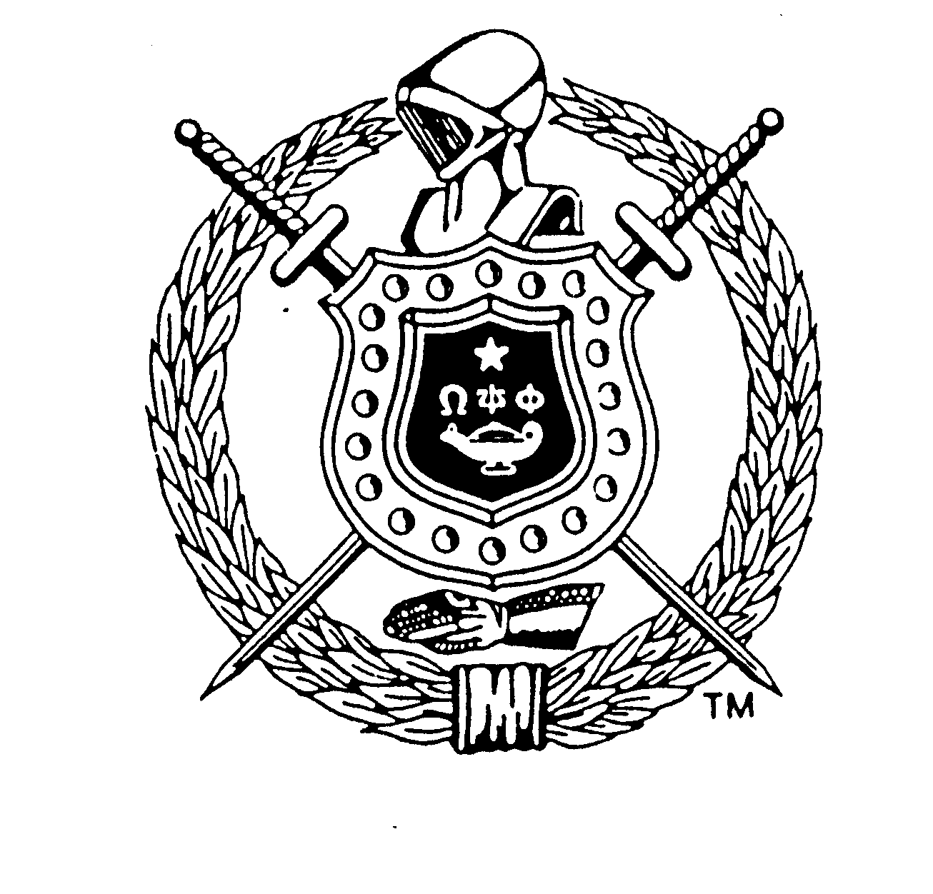
Achievement Week Project 2017
Theme: “When the World Calls, Omega Men Answer”
Omega Psi Phi Fraternity, Inc.
Annual International Achievement Week Observance:
November 15-21, 2017
Psi Pi Chapter’s
Local High School Essay Contest:
Local: Award Amt: 1st Scholarship $750.00, 2nd Scholarship $500.00, 3rd Scholarship $250.00
1st Place Local Essay Advance to District Level: Award Amt: $1000 Scholarship
1st Place District Advance to IHQ: Award Amt: 1st Scholarship: $5,000; 2nd Scholarship: $3,000; 3rd Scholarship: $2,000; 4th Scholarship: $1,000.

Eligibility: The Local Essay Contest is open to all College-Bound, High School Seniors
Clarksville/Montgomery County School System/Ft. Campbell High School
Hopkinsville/Christian County School District
RULES
The essay must be entitled:
“What Actions Can You Take to Promote Social Justice and Embrace Diversity of All People”
“The essay must be Original neither previously published nor secured by copyright. The essay must be between 700 and 750 words in length.
Three type-written, double-spaced copies must be submitted via postal service and the following information for the contestant Must Appear on the First Page in this manner:

Title: __________________________________________________________________________________
An Essay By: ___________________________ Home Street Address: ____________________________
City, State, Zip Code: _______________________ Name of High School: _________________________
Address of High School: _________________________________________________________________
Contest Name: Omega Psi Phi Fraternity International High School Essay Contest
Name of Chapter: __________________ Location of Chapter: ___________________

The manuscript must be postmarked by October 21st, 2017 and sent to
*****PSI PI CHAPTER P.O. BOX 2903 CLARKSVILLE, TN. 37042*****

Persons submitting manuscripts thereby grant to Psi Pi Chapter the right to keep the manuscripts and to exercise full publishing rights to them. Awards will be announced on or about November 11th, 2017 and the decision of the judge(s) will be final. The manuscripts must present an adequate treatment of the essay topic. Winners will be required to furnish written proof that they were enrolled in their respective high school at the time the essays were submitted. Awards will be submitted to each winner at the Psi Pi Chapter Annual Achievement Week Banquet. Winner essay will be forward to District / International Head Quarters to enter that contest.
RATING CRITERIA FOR ESSAYS
- Development of Topic/Thesis: (30 possible pts.) Topic well developed (covers and develops major points, supplying enough information for understanding)
- Progression: (20 possible pts.) Composition progresses from beginning to end in a logical flow of information
- Readability: (25 possible pts.) Concise prose that sticks to the point and does not ramble (holds reader’s attention)
- Grammar: (15 possible pts.) Agreement of subject and verb; proper tense; correct sentence construction; paragraphing, including transitional phrases linking same
- Spelling: (5 possible pts.)
- Punctuation: (5 possible pts.)

